QUIZ WEBSITE

**Project Synopsis**

**Major-Project (IMW651)**

Degree

**BACHELOR OF COMPUTER APPLICATION**

|  |  |
| --- | --- |
| PROJECT GUIDE:  **Mr. Sanjeev Soni**  **Sr.IT Faculty** | SUBMITTED BY:  **Yogika uraf simran (TCA2056028)**  **Saood abbas(TCA2055006)** |

February, 2023



**FACULTY OF ENGINEERING & COMPUTING SCIENCES**

**TEERTHANKER MAHAVEER UNIVERSITY, MORADABAD**

Table of Contents

1 Project Title 3

2 Problem Statement 3

3 Project Description 3

3.1 Scope of the Work 3

3.2 Project Modules 3

4 Implementation Methodology 3

5 Technologies to be used 4

5.1 Software Platform 4

5.2 Hardware Platform 4

5.3 Tools 4

6 Advantages of this Project 4

7 Future Scope and further enhancement of the Project 4

8 Team Details 4

9 Conclusion 5

10 References 5

# Project Title

The project title ‘Quiz Website’. Aim of the Website The Quiz website, This website will provide you MCQ of some different types of subjects which will be very beneficial for students best study and as well student growth.

There are many quiz applications available on the internet but there are some quiz applications are provide a better understanding as well as better co-operative with users. Our aim is also the same, We will provide a good, user-friendly, more understanding, more visual, or easy to use and easy to Grab application for the users. We will provide many pages like Home Page, About-Us, quiz content, result page as well a contact page, log-in, and registration.

# Problem Statement

The quiz is accessed through login and registration if the user is not registered or login yourself first then the user cannot attempt the quiz likewise first, then enter the username and e-mail id which is added to the database. Before the start of the Quiz, the rules and regulations are displayed that include a description of the time limit, the number of questions to be answered, and scoring methods. The quiz is started by displaying Twenty questions with four options each based on the category in Computer Science. If the answer is correct, the score is incremented. If the time exceeds 10 minutes or all the questions are answered the quiz is stopped. The final score will be displayed and updated in the database with the username.

the quiz website has two categories in the particular language subject (HTML, CSS, JavaScript, and so on) first is technical or second is a theoretical quiz.

# Project Description

It is quiz based application where users can attempt the quiz as per the requirement or need of knowing. it has many subjects which are available for the users like HTML, CSS, JavaScript, Python, Node, and so on.

Users can contact us through the website as well and also they can follow us through social media.

## Scope of the Work

The project will allow users to log in/Signup onto the Platform. The Signup process will include the authentication/authorization by the server. On Successful Login, the user will be redirected to the home page of the platform and use that platform for practicing and obtaining knowledge as per requirements.

## Project Modules

This project has numerous modules

1. Home page-this page for those who want to contact us or wants to know about the website and its modules.
2. About-Us-this for intro to the people who are working on the side or what is this in the website
3. Contact-this page for queries about the website or content provided by developers.
4. Login/Registration page- this page is for login or registration for old and new users.
5. Content- this page has content about the quiz and this page will be connected with the sub-content pages about the subjects
6. Quiz result page-this page will show the result of the quiz and so on.

# Implementation Methodology

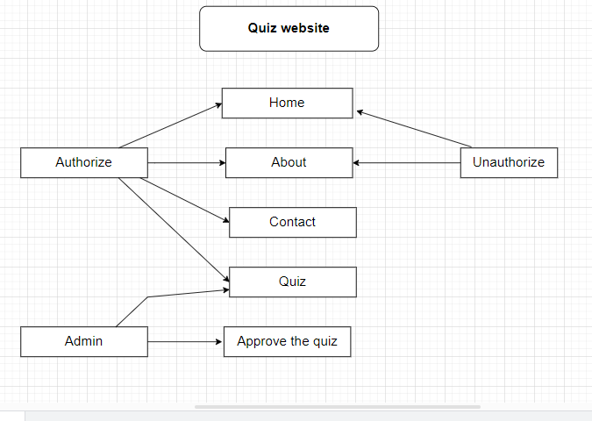

# Technologies to be used

The following technologies are utilized for this project. This list may change as need for more features/improvements arises in the future.

#### 6.1 Software Platform

1. **Front-end:- :** A front end developer has one general responsibility: to ensure that website visitors can easily interact with the page. They do this through the combination of design, technology and programming to code a website's appearance, as well as taking care of debugging.

* **HTML5:** HTML 5 is a revision of the Hypertext Markup Language (HTML), the standard programming language for describing the contents and appearance of Web pages. HTML5 was developed to solve compatibility problems that affect the current standard, HTML4.

* **CSS3:** CSS3 stands for Cascading Style Sheet level 3, which is the advanced version of CSS. It is used for structuring, styling, and formatting web pages. Several new features have been added to CSS3 and it is supported by all modern web browsers.

* **Bootstrap:** Bootstrap is a free, open source front-end development framework for the creation of websites and web apps. Designed to enable responsive development of mobile-first websites, Bootstrap provides a collection of syntax for template designs.

* **JavaScript:** Bootstrap is a free, open source front-end development framework for the creation of websites and web apps. Designed to enable responsive development of mobile-first websites, Bootstrap provides a collection of syntax for template designs.

1. **Back-end:-** The back end refers to parts of a computer application or a program's code that allow it to operate and that cannot be accessed by a user. Most data and operating syntax are stored and accessed in the back end of a computer system. Typically the code is comprised of one or more programming languages.

* **Node.JS:** Node.js (Node) is an open source development platform for executing JavaScript code server-side. Node is useful for developing applications that require a persistent connection from the browser to the server and is often used for real-time applications such as chat, news feeds and web push notifications.

***Express:** Express is a minimal and flexible Node.js web application framework that provides a robust set of features to develop web and mobile applications. It facilitates the rapid development of Node based Web applications.

#### Hardware Platform

* 4 GB RAM

* 500gb Hard Disk, * Windows 10,

* Google Chrome v105.0.5195.

#### 6.3 Tools, if any

The main tool is Atom 1.60.0. Atom is a free and open-source text and source code editor for mac OS, Linux, and Microsoft Windows with support for plug-ins written in JavaScript, and embedded Git Control. Developed by GitHub, Atom is a desktop application built using web technologies.

Atom enables users to install third-party packages and themes to customize the features and looks of the editor, so you can set it up according to your preferences and with ease ([**Atom**](https://atom.io/)). It is as welcoming to a newbie as it is for an experienced developer.

# Advantages of this Project

1. Quizzes are good for revision-

Quizzes can be a useful tool for revision because they can help students to recall information that they have learned in a structured way. By answering quiz questions, students can identify areas where they may need to focus their studying and can review concepts that they may have forgotten.

1. Quizzes are great for end of topic assessments-

Quizzes can be an effective way to assess student understanding of a particular topic. By testing students' knowledge at the end of a unit or topic, teachers can identify areas where students may need more support and adjust their teaching accordingly.

1. Quizzes raise confidence-

Quizzes can help to build students' confidence by providing a low-stakes opportunity to demonstrate their knowledge. When students are able to answer quiz questions correctly, they may feel more confident in their ability to learn and retain information.

1. Quizzes are fun-

Some students may find quizzes to be fun, particularly if they enjoy competition or the challenge of answering questions correctly. However, other students may find quizzes to be stressful or anxiety-inducing, particularly if they feel like their performance is being evaluated.

1. Students tend to actually read the material-

Quizzes may motivate students to read the material in order to prepare for the quiz. However, students may also try to rely on memorization rather than deep understanding of the material in order to perform well on quizzes.

1. Students show up for class on time since the quiz always comes first-

The possibility of a quiz may encourage students to show up for class on time or to complete readings in advance. However, this may also create a sense of pressure or anxiety that could negatively impact their learning.

1. Students are placed in the right attitude for learning-

Taking a quiz may help to focus students' attention and put them in a mindset that is conducive to learning. However, this may not be true for all students, and some may feel stressed or anxious during quizzes.

# Future Scope and further enhancement of the Project

In the future, According to the users, add new features and more interactive design can be considered. It can help foster a sense of community and encourage peer to peer interaction and improve learner engagement. Discussion can take the form of debate or reflective sharing, giving learners the opportunity to expand upon and clarify their understanding of key ideas.

# Team Details

| **Project Name & ID** | **Course Name** | **Student ID** | **Student Name** | **Role** | **Signature** |
| --- | --- | --- | --- | --- | --- |
|  | Major-Project (IMW651) | TCA2056028 | YOGIKA URAF SIMRAN | Designer  Developer  Tester |  |
| TCA2055006 | SAOOD ABBAS | Designer  Developer  Tester |  |
|  |  |  |  |
|  |  |  |  |
|  |  |  |  |

# Conclusion

In conclusion, quizzes can be a useful tool for learning and assessment, but their effectiveness depends on how they are implemented and how students respond to them. Quizzes can help students to review and retain information, assess their understanding of a topic, build confidence, and prepare for class. However, quizzes may also create stress and anxiety, and their emphasis on memorization may not always encourage deep understanding of the material. Ultimately, the use of quizzes as an educational tool should be balanced with other forms of learning and assessment, and tailored to the needs and preferences of individual students.

# References

[*https://www.w3schools.com/quiztest/*](https://quizizz.com/?lng=en)

[*https://www.geeksforgeeks.org/geeksquiz-home/*](https://quizizz.com/?lng=en)

[*https://quizizz.com/?lng=en*](https://quizizz.com/?lng=en)

[*https://interactives.ck12.org/plix/arithmetic/?gclid=CjwKCAiA_6yfBhBNEiwAkmXy5-YnQLo7tMl6EHn3VaJtyZZucY1Fm5PNXVvcBhg4DVGTrySyeF3QBxoC71wQAvD_BwE*](https://interactives.ck12.org/plix/arithmetic/?gclid=CjwKCAiA_6yfBhBNEiwAkmXy5-YnQLo7tMl6EHn3VaJtyZZucY1Fm5PNXVvcBhg4DVGTrySyeF3QBxoC71wQAvD_BwE)